**CODING CHALLENGES (PETPETALS)**

**Task**

1. Provide a SQL script that initializes the database for the Pet Adoption Platform ”PetPals”.

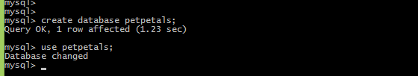

2. Create tables for pets, shelters, donations, adoption events, and participants.

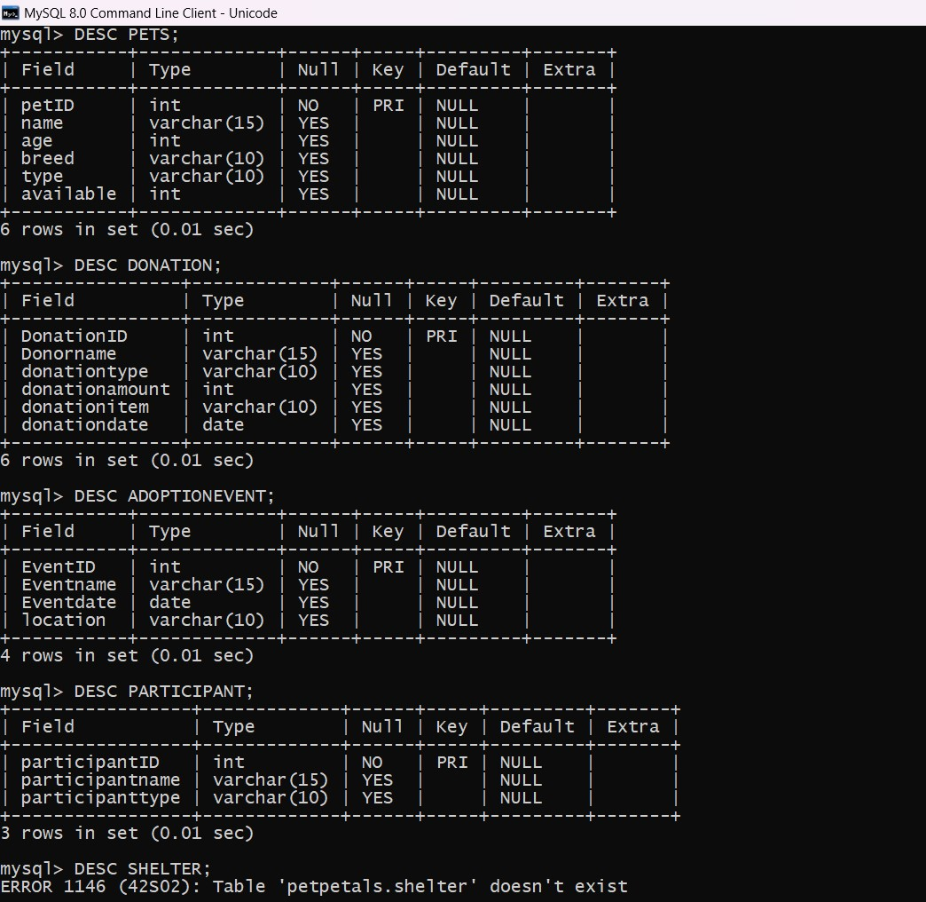

3. Define appropriate primary keys, foreign keys, and constraints



4. Ensure the script handles potential errors, such as if the database or tables already exist.

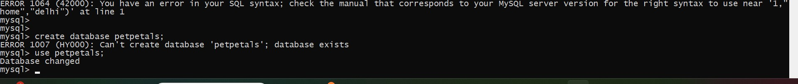

5. Write an SQL query that retrieves a list of available pets (those marked as available for adoption)from the "Pets" table. Include the pet's name, age, breed, and type in the result set. Ensure that the query filters out pets that are not available for adoption.

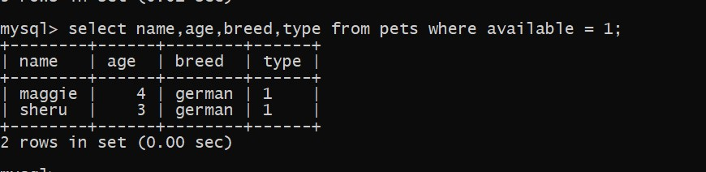

7. Create a stored procedure in SQL that allows a shelter to update its information (name and location) in the "Shelters" table. Use parameters to pass the shelter ID and the new information.Ensure that the procedure performs the update and handles potential errors, such as an invalid

shelter ID.



8. Write an SQL query that calculates and retrieves the total donation amount for each shelter (by shelter name) from the "Donations" table. The result should include the shelter name and the total donation amount. Ensure that the query handles cases where a shelter has received no

donations.



9. Write an SQL query that retrieves the names of pets from the "Pets" table that do not have an owner (i.e., where "OwnerID" is null). Include the pet's name, age, breed, and type in the result set.

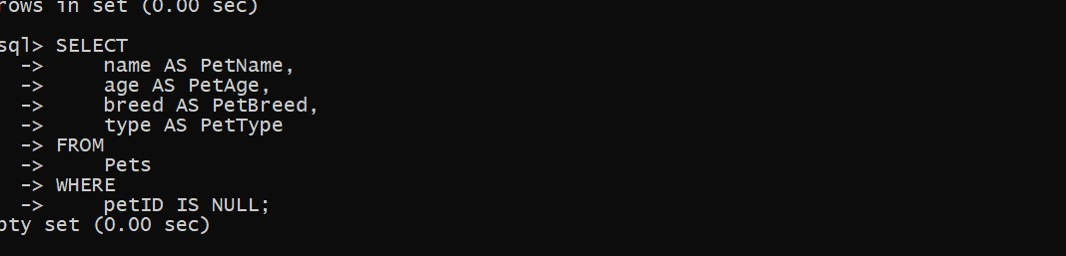

11 Retrieve a list of distinct breeds for all pets that are either aged between 1 and 3 years or older than 5 years..

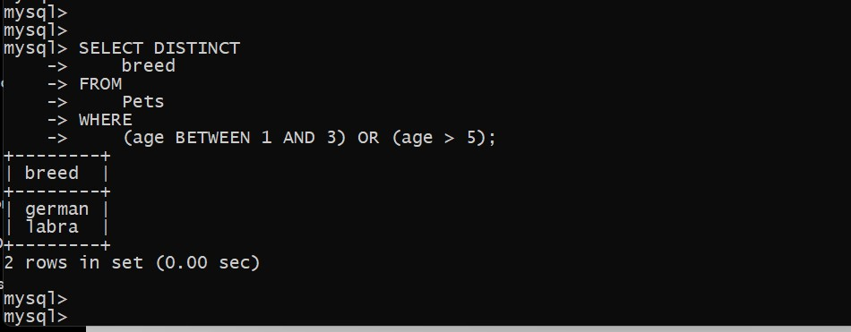

12. Retrieve a list of pets and their respective shelters where the pets are currently available for adoption.

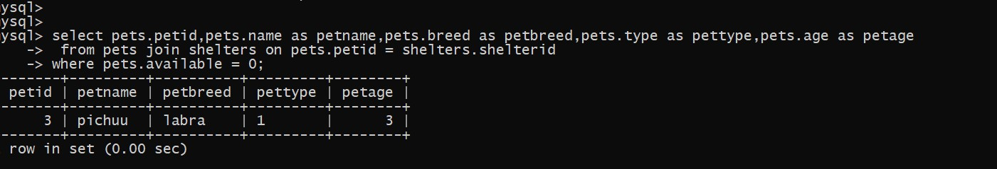

14. Retrieve a list of unique breeds for pets with ages between 1 and 5 years

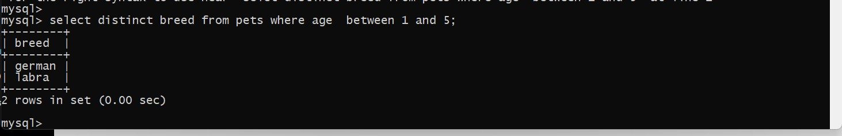

15. Find the pets that have not been adopted by selecting their information from the 'Pet' table

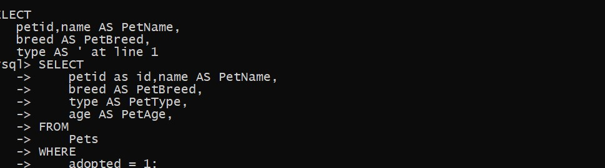

 19.List all possible combinations of shelters and adoption events.

